Doctor Appointment scheduler
Name: K.Kaviarasan
Course: ASP Dot Net
Project Guide: Yovan Doss X
S.NO | TOPICS | PAGE NO
1 | Introduction | 1.1
2 | Scope | 1.1
3 | Objectives | 1.1
4 | Modules/Features | 2.2
5 | Workflow/ER Diagram | 3.3
6 | Table Design | 4.5
7 | Time Duration | 5.6
8 | Layout Design | 6.1

1. Introduction
The Doctor Appointment Booking System is designed to enhance the healthcare appointment scheduling experience for patients, doctors, and super admins. It facilitates an efficient and user-friendly platform where patients can easily book, reschedule, and manage appointments, while doctors can view and manage their schedules. Super admins will have full control over managing doctor and patient data, appointments, and system settings. This system aims to reduce manual workload, improve efficiency, and ensure smooth management of appointments.
2. Scope
The scope of the Doctor Appointment Booking System is to develop an integrated platform that facilitates the management of patient appointments, doctor schedules, and administrative controls. The system will include functionalities for patient registration, appointment booking, doctor availability management, and overall appointment monitoring by the super admin.
The system will aim to:
- Provide an easy-to-use interface for patients to book, reschedule, or cancel appointments.
- Allow doctors to manage their daily appointments, apply for leave, and ensure availability.
- Enable super admins to manage doctor and patient data, oversee appointments, and implement necessary appointment blocks.
The solution will be scalable, secure, and accessible, focusing on improving appointment scheduling efficiency and user experience for all stakeholders.
3. Objectives
- Easy Appointment Booking:
Allow patients to easily register, book, reschedule, or cancel appointments online.
- Manage Doctor Schedules:
Enable doctors to view and manage their appointments, and apply for leave when needed.
- Admin Control:
Give super admins the ability to manage patient and doctor information, and oversee all appointments.
- Secure Payment Integration:
Add a secure way for patients to pay online to confirm their appointments.
- Better Patient Experience:
Provide patients with the ability to track their past and upcoming appointments.
- Scalable and Secure System:
Ensure the system is safe and can grow as more data is added.
- Improve Efficiency:
Automate appointment management to reduce manual work and make the system more efficient.

4. Modules / Features
1. Patient Module:
- Registration/Login:
  - Patients can create an account or log in using their Patient ID.
- Appointment Booking:
  - Select a date, department, doctor, and available time slot.
  - Payment integration for confirming appointments.
- Appointment Management:
  - View past, upcoming, and cancelled appointments.
  - Reschedule or cancel appointments if needed.
2. Doctor Module:
- Login & Profile Management:
  - Doctors can log in securely using credentials created by the Super Admin.
- Appointment Calendar:
  - View daily appointments in a calendar format.
  - Manage appointments by confirming, cancelling, or adjusting availability.
- Leave Management:
  - Doctors can apply for leave, which automatically blocks their slots from being booked during their absence.

3. Super Admin Module:
- Master Data Management:
  - Manage doctor and patient data (profiles, schedules, etc.).
- Appointment Monitoring:
  - View all scheduled appointments by doctor and patient.
- Appointment Blocking:
  - Block appointments for a specific doctor when needed (e.g., for emergencies or leave).
- Doctor & Patient Management:
  - Add, update, or delete doctor and patient profiles as needed.
4. Payment Module:
- Payment Integration:
  - Secure online payment gateway for patients to confirm appointments.
5. Notifications Module (Optional):
- Appointment Reminders:
  - Send automatic reminders for upcoming appointments to both patients and doctors.
- Status Notifications:
  - Notify patients of appointment confirmations, cancellations, or reschedules.
5. Workflow / ER Diagram
Workflow:
Doctor List → Calendar → Book Slot → Appointment Confirmation → Reschedule/Cancel
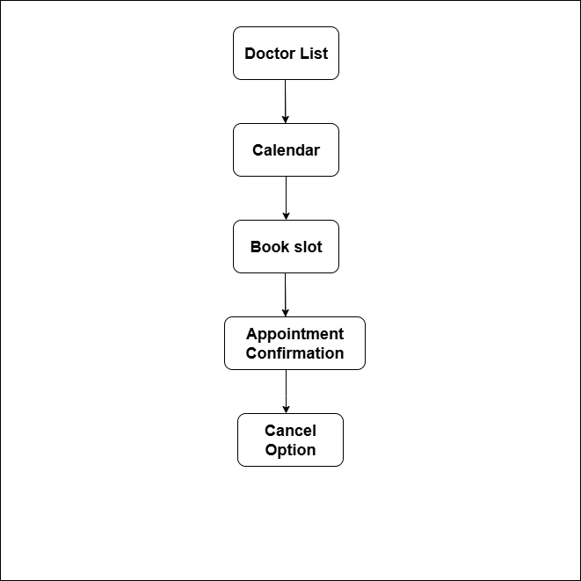

6.Table Design
Table Name:User table
Column Name | Data Type | Length | Constraint | Description
UserID | UUID | — | DEFAULT uuid_generate_v4(), PRIMARY KEY | Unique User ID (auto-generated UUID)
DoctorID | VARCHAR | 50 | NOT NULL | Doctor ID (string)
DoctorName | VARCHAR | 255 | NOT NULL | Full name of the doctor (First Name, Last Name)
Specialization | VARCHAR | 100 | — | Medical specialty (e.g., Cardiology, Dermatology)
Gender | ENUM | — | Values: ('Male', 'Female', 'Other') | Gender of the doctor
DateOfBirth | DATE | — | — | Doctor’s date of birth
PhoneNumber | VARCHAR | 15 | NOT NULL | Contact number (with format validation)
Address | VARCHAR | 255 | — | Contact address
Username | VARCHAR | 100 | NOT NULL, UNIQUE | Unique username for login
Password | VARCHAR | 255 | NOT NULL | Secure encrypted password for login
ConfirmPassword | VARCHAR | 255 | NOT NULL | Re-entered password for confirmation
Role | ENUM | — | NOT NULL, Values: ('Doctor', 'Admin') | Role of the user
YearsOfExperience | INT | — | — | Number of years the doctor has been practicing
Qualification | VARCHAR | 100 | — | Highest qualification (e.g., MBBS, MD)
ConsultationFee | DECIMAL | (10,2) | — | Consultation fee for appointments
StartTime | TIME | — | — | Start time for doctor availability
EndTime | TIME | — | — | End time for doctor availability
isActive | BOOLEAN | — | DEFAULT TRUE | Status flag if doctor is active
isDelete | BOOLEAN | — | DEFAULT FALSE | Status flag if doctor record is deleted

Table Name:Booking Appointment table

Column Name | Type | Description
PatientId | UUID | Primary Key, auto-generated with gen_random_uuid()
TitleId | UUID | Foreign Key → Titles(TitleId) (e.g., Mr., Mrs., Dr.)
Name | VARCHAR(255) | Patient full name (required)
Gender | SMALLINT | Gender code (0=Male, 1=Female, 2=Other, etc.)
DOB | TIMESTAMP | Date of Birth
Mobile | VARCHAR(20) | Mobile number
Email | VARCHAR(255) | Email address
MaritalStatusId | UUID | Foreign Key → MaritalStatus(MaritalStatusId)
OccupationId | UUID | Foreign Key → Occupations(OccupationId)
NationalityId | UUID | Foreign Key → Nationalities(NationalityId)
State | VARCHAR(100) | State of residence
PinCode | VARCHAR(20) | Postal/ZIP code
Address | VARCHAR(500) | Full residential address
IsActive | BOOLEAN | Account status (default = TRUE)
Username | VARCHAR(100) | Unique login username
Password | VARCHAR(255) | Login password (should be hashed)

Column Name | Data Type | Length | Constraint | Description
countryId | UUID | N/A | PRIMARY KEY, DEFAULT gen_random_uuid() | Unique identifier for each record
countryName | VARCHAR | 100 | NOT NULL | Name of the country
isDeleted | BIT | N/A | DEFAULT FALSE | Soft delete flag (default is false)

Table Name:country table
Description:

Table Name:marital status table
Description:

Column Name | Data Type | Length | Constraint | Description
maritalStatusId | UUID | N/A | PRIMARY KEY, DEFAULT gen_random_uuid() | Unique identifier for each record
maritalStatus | VARCHAR | 50 | NOT NULL | Marital status (e.g., Married, Single)
isDeleted | BIT | N/A | DEFAULT FALSE | Soft delete flag (default is false)

Table Name:Relationship table
Description:
Column Name | Data Type | Length | Constraint | Description
relationshipId | UUID | N/A | PRIMARY KEY, DEFAULT gen_random_uuid() | Unique identifier for each record
relationshipName | VARCHAR | 50 | NOT NULL | Name of the relationship (e.g., Father, Mother)
isDeleted | BIT | N/A | DEFAULT FALSE | Soft delete flag (default is false)

Table Name:Occupation table
Description:

Column Name | Data Type | Length | Constraint | Description
occupationId | UUID | N/A | PRIMARY KEY, DEFAULT gen_random_uuid() | Unique identifier for each record
occupationName | VARCHAR | 100 | NOT NULL | Name of the occupation (e.g., Engineer, Doctor)
isDeleted | BIT | N/A | DEFAULT FALSE | Soft delete flag (default is false)

Table Name:Religion and Title table
Description:
Column Name | Data Type | Length | Constraint | Description
religionId | UUID | N/A | PRIMARY KEY, DEFAULT gen_random_uuid() | Unique identifier for each record
religionName | VARCHAR | 100 | NOT NULL | Name of the religion (e.g., Christianity, Islam)
isDeleted | BIT | N/A | DEFAULT FALSE | Soft delete flag (default is false)
Column Name | Data Type | Length | Constraint | Description
titleId | UUID | N/A | PRIMARY KEY, DEFAULT gen_random_uuid() | Unique identifier for each record
titleName | VARCHAR | 50 | NOT NULL | Name of the title (e.g., Mr., Mrs., Dr.)
isDeleted | BIT | N/A | DEFAULT FALSE | Soft delete flag (default is false)

7. Time Duration (4-Day Execution Plan)
Day 1 – Database & Setup
- Install & configure SQL Server.
- Create database schema with tables:
  - Users (patients, admins)
  - Doctors
  - Appointments
- Define relationships & foreign keys.
- Test DB connection with sample queries.
- Connect SQL Server to .NET backend (Entity Framework or ADO.NET).

Day 2 – Backend API Setup
- Set up .NET project structure (Web API).
- Implement authentication (basic login/signup).
- Create API for Doctor List (GET doctors).
- Use Swagger/Postman to validate endpoints.

Day 3 – Appointment APIs
- Build APIs for:
  - Calendar availability (GET slots).
  - Book appointment (POST).
  - Confirm appointment (PUT).
- Add validation for overlapping appointments.
- Test with sample requests in Postman.

Day 4 – Appointment Management
- Implement APIs for:
  - Reschedule appointment (PUT).
  - Cancel appointment (DELETE).
- Add status tracking (Booked, Confirmed, Rescheduled, Cancelled).
- Write unit tests for all appointment APIs.

Day 5 – Frontend (Doctor & Calendar)
- Set up frontend project (React/Angular).
- Create Doctor List page with search & filter.
- Create Calendar selection UI for appointment slots.
- Integrate with backend API for doctor data.

Day 6 – Frontend (Booking & Confirmation)
- Build booking form (patient details, reason for visit).
- Display appointment confirmation page.
- Show booked slot details (doctor, date, time).
- Implement form validation & error handling.

Day 7 – Integration & Testing
- Connect all frontend components with backend APIs.
- End-to-end flow: Doctor → Calendar → Book → Confirm → Reschedule/Cancel.
- Populate DB with demo doctors & appointments.
- Conduct functional testing with sample users.

Day 8 – Finalization & Documentation
- Perform integration testing (backend + frontend).
- Fix bugs and optimize queries/APIs.
- Write project documentation:
  - ER Diagram & schema.
  - API endpoints list.
  - Screenshots of UI.
  - Setup/installation steps.
- Prepare presentation/demo version.

Layout Design:

Login Page


Register Page

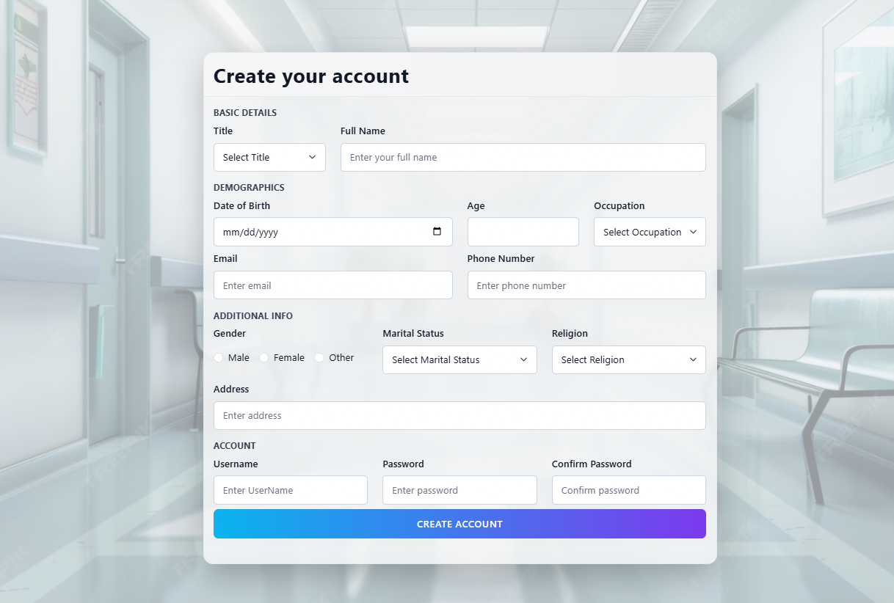

Home Page


Doctor Page

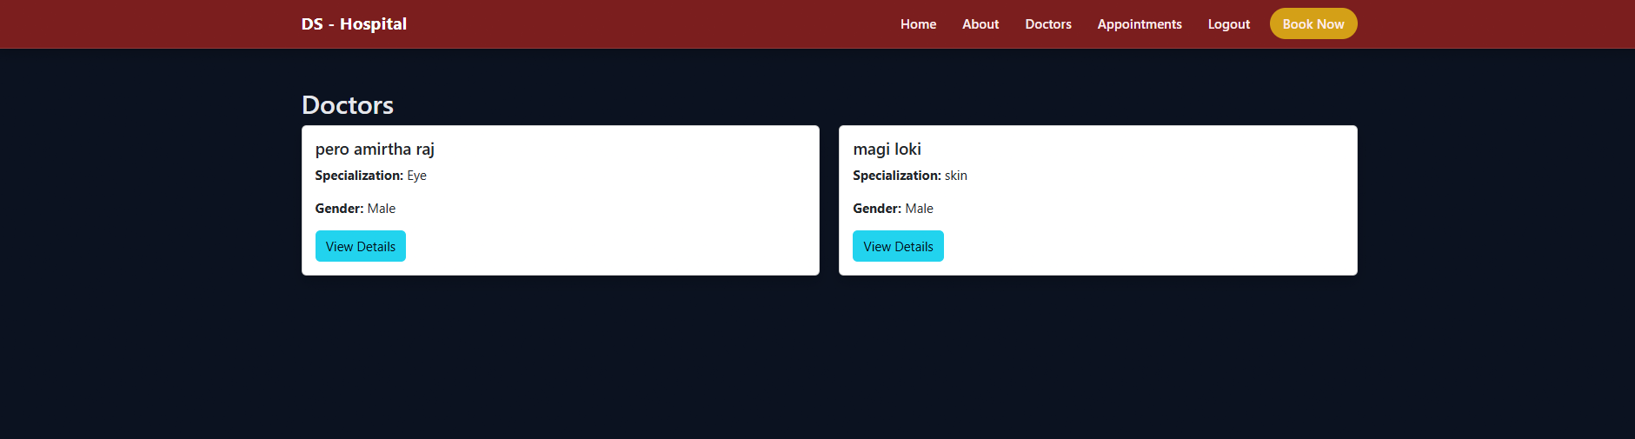

Doctor Details Page
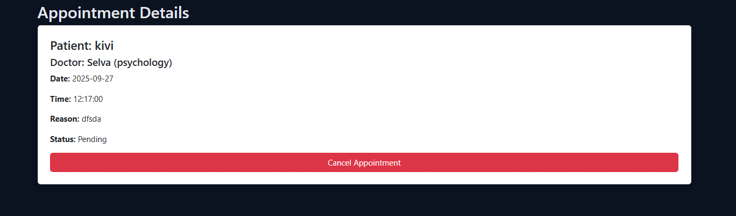

Book Appointment Page
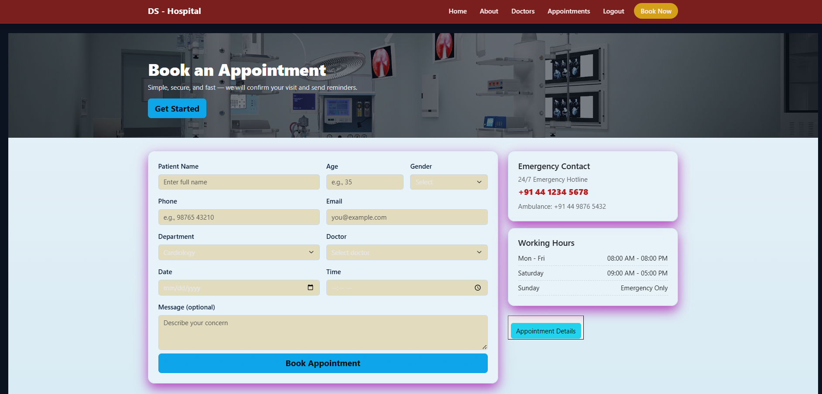

Appointment Booking Details
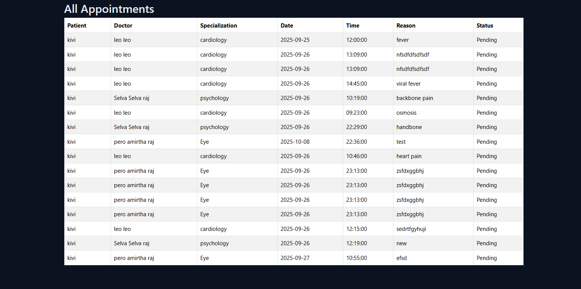

Appointment Cancel Page


